An adapter helps two incompatible functionalities to work together. Ex: We bought laptop from US. The plug will not set in Indian current plug. Now we need to put Adapter to fit in.
Collections.sort which internally uses Arrays.sort

Problem Scenario:
- Set of interfaces and classes are working fine.
- New Requirements to modify/update the implementation.
Wrong Solution:
- Update the existing implementation class
Write Solution
- Define a new adapter interface that extends or composite the class
- Modify list of methods that needs changes.



- In the below example, there is a sort functionality which accepts int[] and returns int[] and it is used by client1.
- Now client2 asks for a sort functionality which accepts List<Integer> and returns List<Integer>.
- Then here we don’t have to write another functionality. Create Adapter, convert List<Integer> to int[] call existing sort.

package com.sample.designpattern;

import java.util.ArrayList;
import java.util.Arrays;
import java.util.List;
import java.util.stream.Collectors;
import java.util.stream.IntStream;

public class AdapterTest {
public static void main(String[] args) {
int[] numbers = new int[] { 34, 2, 4, 12, 1 };
Sorter sorter = new ArraySorter();
numbers = sorter.sort(numbers);
for(int i=0; i<numbers.length; i++) {
System.out.println(numbers[i]);
}

List<Integer> intList = new ArrayList<>();
intList.add(10);intList.add(5);intList.add(20);
ListSorter listSorter = new SortListAdapter();
intList = listSorter.sort(intList);
intList.stream().forEach(System.out::println);
}
}

interface Sorter {
public int[] sort(int[] numbers);
}

class ArraySorter implements Sorter {
@Override
public int[] sort(int[] numbers) {
Arrays.sort(numbers);
return numbers;
}
}

interface ListSorter {
public List<Integer> sort(List<Integer> numbers);
}

class SortListAdapter implements ListSorter {
@Override
public List<Integer> sort(List<Integer> numbers) {
// convert the List to a array
int arrayInt[] = numbers.stream()
.mapToInt(currentValue -> currentValue).toArray();
ArraySorter arraySorter = new ArraySorter();
arrayInt = arraySorter.sort(arrayInt);
// convert the array to a List
numbers = IntStream.of(arrayInt).boxed().collect(Collectors.toList());
return numbers;
}
}

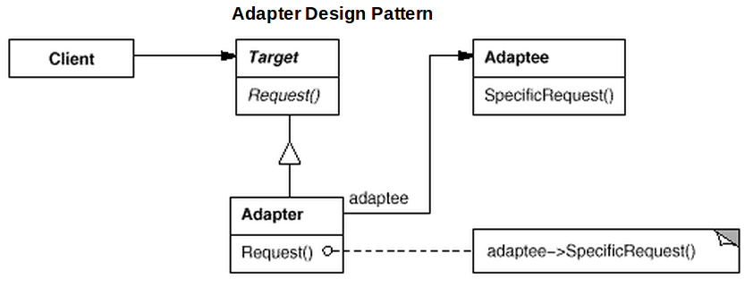

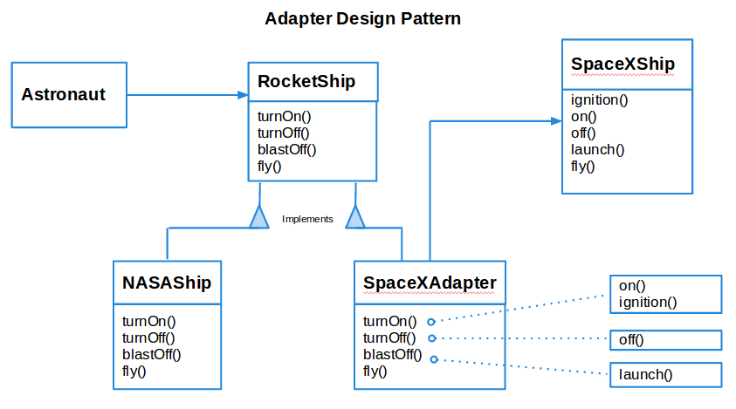
Adapter design pattern can be implemented in two ways. One using the inheritance method and second using the composition method.

Real World Example on Adapter Design Pattern:
Enumerator and Iterator

